AVL Trees:

The imbalance is caused by two cases:

(1) The new insertion occurred into
the left subtree of the left child of the deepest unbalanced node; or
the right subtree of the right child of the deepest unbalanced node.

(2) The new insertion occurred into
the right subtree of the left child of the deepest unbalanced node; or
the left subtree of the right child of the deepest unbalanced node.

Example 1 – single rotation:

Suppose we insert 19 into an existing AVL tree, both node 9 and 20 become unbalanced. But node 9 is the deepest unbalanced node. So we do rotation among its subtree.

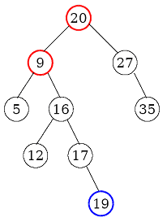

Since 19 is inserted in the RIGHT subtree of the RIGHT child (16) of the deepest unbalanced node 9, this situation belongs to case 1. We just need do the single rotation to rotate this node with its child as follows.

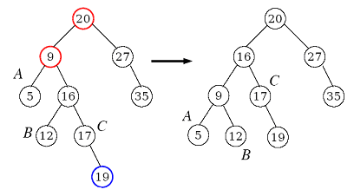

Example 2 -- double rotation:

Suppose we insert 11 into an existing AVL tree, both node 9 and 20 become unbalanced. But node 9 is the deepest unbalanced node. So we do rotation among its subtree.

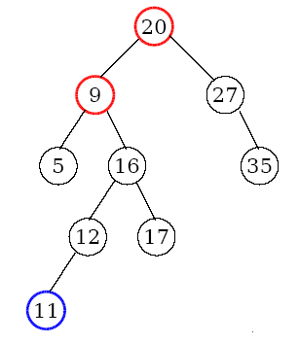

Since 11 is inserted in the LEFT subtree of the RIGHT child (16) of the deepest unbalanced node 9, this situation belongs to case 2. We need do the double rotation. First rotate the child and grandchild of the deepest unbalanced node. Next rotate the deepest unbalanced node with its child in the new tree after the first rotation.

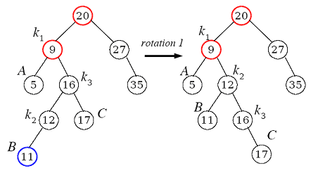

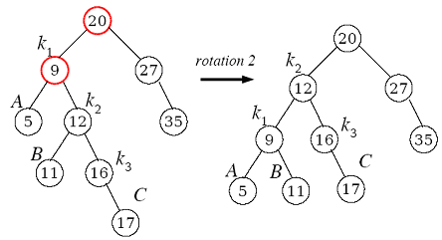

Construction of AVL-Tree for the list 5, 6, 8, 3, 2, 4, 7

5
/ \
- 7
/ \ / \
2 4 6 8

